Our story began in October 2017 when we first met during our Mathematics Wizards Society’s General Assembly. At that time, I only knew Cha as the girl who captivated everyone with her dance presentation. After the assembly, we became friends, and as time passed, my admiration for her grew deeper. There were several attempts at courtship along the way, but our love story needed more time to unfold. Despite the setbacks, my feelings remained constant. Finally, in December 2020, I officially courted her with sincere intentions. After months of patience, prayers, and perseverance, she said "yes" on July 8, 2021. Making it the most unforgettable birthday gift I could ever receive. Over the years, our relationship blossomed through countless memories, challenges, and milestones that strengthened our bond. Then, on August 2, 2025, at the beautiful Riverfront Garden Resort in Maragondon, Cavite, I asked the love of my life to marry me. Surrounded by the serenity of the moment and the love we had built together, she said "yes" once again. From a chance meeting in 2017 to a promise of forever, our journey is a testament to patience, faith, and a love that was truly meant to be.

Venue:
Riverbank Garden Events
130 Don P. Campos Avenue, San Agustin 2, Dasmariñas, Cavite

Attire:
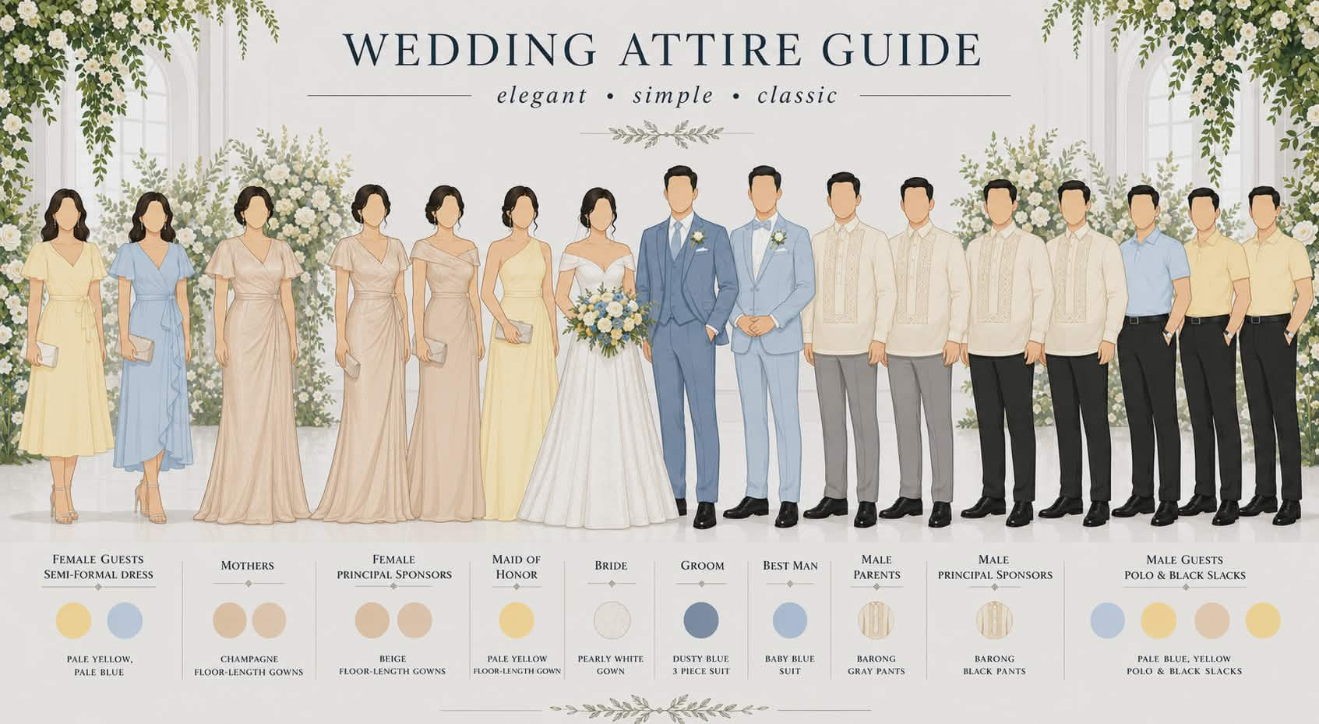

Entourage:

Officiant
Ceasar Gustillo

Groom’s Men
Isiah Pritz Campos – Best Man
John Paul Cerezo
Arvin Josiah Dela Cruz
Michael Madrid
Kimuel Diaz
Eric James Mase
Lester John Quintos

Bridesmaids and Bridesmen
Hanna May Rosales – Maid of Honor
Lawrence Palen
Trista Magdaraog
Jennylyn Selga
Ma. Lhoravel Emerenciana
Vanessa Catherine Belgado
Joshua Martinez
Emmanuel Oscar Abeleda

Ninongs
Leo M. Catedrilla
Joseph Nietes
Jomarie Catedrilla
Romnick Catedrilla
Jordan Del Mundo
Celestino Banlaygas
Roden Samson
Simon Paller

Ninangs
Ladivina Leopando
Pie Nietes
Mommy ni Hanna
Gerlyn Mae Catedrilla
Arlyn Del Mundo
Amor Ramos
Jojie Adelante
Jessamine Paller

Ring Bearer
Jaben Blake Britania

Coin/Check Bearer
Myrrh Emmanuel Bacay

Bible Bearer
Hezekiah Pabunan

Flower Girls
Zeinnah Khaye Sapio
Zeibrielle Ellise Sapio

Wedding Timeline:
